# Workshop

Workshop for the ["Software Engineering and DevOps" course @ SoftUni](https://softuni.bg/trainings/4118/software-engineering-and-devops-june-2023).

## ToDo App

The TODO **app** (provided in the **resources**) is a simple app for **adding tasks**. It is a React **application** with a NodeJS **backend** and a MongoDB **database**. We should **create separate** Docker **containers** and **connect them in two networks** as shown below to make the **three containers work together**:

Then, we should set up a **workflow**, in which **whenever** we make **changes** to our **codebase** and **push** those **changes** to our **GitHub repository**, the following should happen:

* **GitHub Actions** will **detect** the **push event** and **trigger** the **workflow**.
* The **workflow** **checks** out our **codebase**, sets up **Docker** **Buildx**, and **logs** into **Docker** **Hub**.
* For **each job** (**build-frontend** and **build-backend**), the workflow will build a **Docker image** using the **Dockerfile** provided in the context directory (**./frontend** or **./backend**).
* After building the Docker images, the workflow will push these images to the Docker Hub under your username and with the tag frontend:latest or backend:latest respectively.

This way, we can be sure that our Docker images on Docker Hub always represent the latest state of our codebase on the **main** branch.

Now, let's start with the **docker-compose** file. We have some requirements that we have to follow:

* Specify the version of Docker Compose file format being used;
* List the services (containers) that make up our application;
  + frontend
  + backend
  + mongo
* Build the Docker images for the **frontend** and **backend** services using the **Dockerfiles** found in the **./frontend** and **./backend** directories
* Mount directories from our host machine into the Docker container;
  + Map the **./frontend** directory on our host to **/usr/src/app** in your **frontend** container;
  + Map the **./backend** on our host to **/usr/src/app** in your backend container;
* Map ports between the Docker host and containers.
  + For the frontend service, it's mapping port **3000** on our host to port **3000** in the container.
* List the networks the service should connect to.
  + The **frontend** service is connected to the **react-express** network;
  + The **backend** service is connected to both **react-express** and express-mongo networks;
  + **MongoDB** is connected to **express-mongo** network.
* Use the **mongo:latest** image directly from Docker Hub, instead of building from a local Dockerfile.
  + Mount the **./data** directory from our host to **/data/db** inside the container, where MongoDB stores its data.
* Define the networks to be used by services.

The file should look like this:

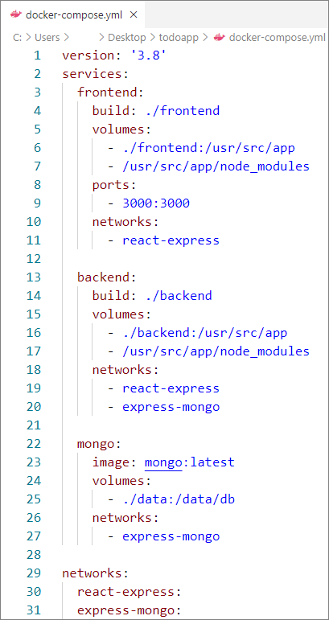

Now let's test if everything works correctly. Open a terminal in the project directory and run the following command:



The containers should appear in Docker:

When ready, we should be able to **add tasks** to the **TODO** **list** **in the app**:

Now, let's define the CI/CD workflow in GitHub actions.

First, create a **GitHub** repo that will hold the folders for the **frontend** and **backend** services.

Then, go to Docker Hub and if you don't have an account, create one.

After you have set up your account, create two repos – one for each service:

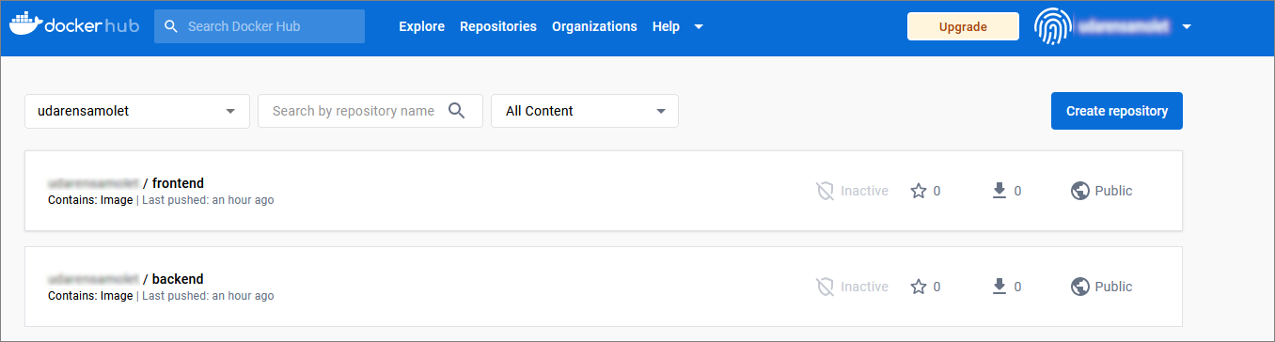

Then, while still in Docker Hub, go to your **Account** → **Account Settings** → **Security** → **Access** **Tokens** and create a new access token that we will use for our GitHub repo:

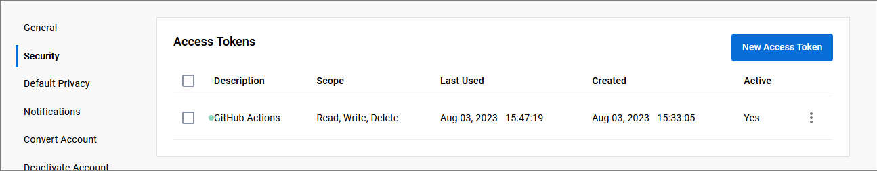

Now, go to your GitHub repo and add this access token as a secret. You should add another secret, containing your Docker account:

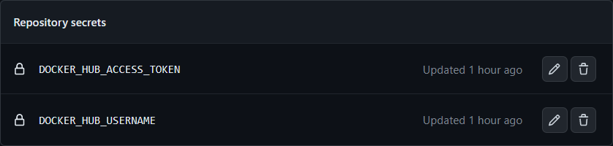

Now, let's set up the workflow:

* Define the name of the workflow;
* Specify that the workflow should be triggered when changes are pushed to the main branch of the repository;
* Define the jobs:
  + One job for each service;
  + Set the type of runner;
  + Define the steps to be taken in order to execute the tasks in the job:
    - Check out the repo
    - Set up QEMU
    - Set up Docker Buildx
    - Login to Docker Hub
    - Build and push

The **main.yaml** file should look like this:

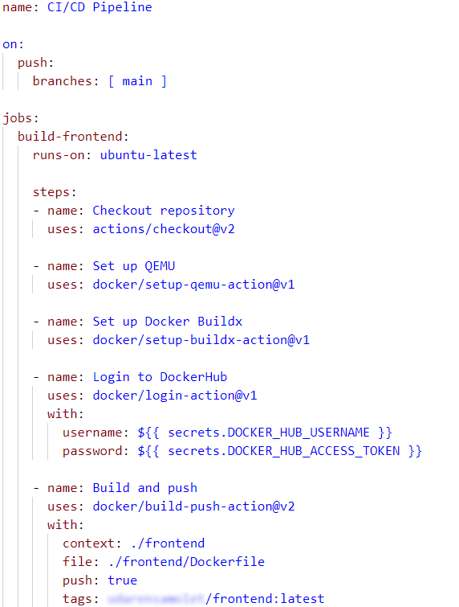

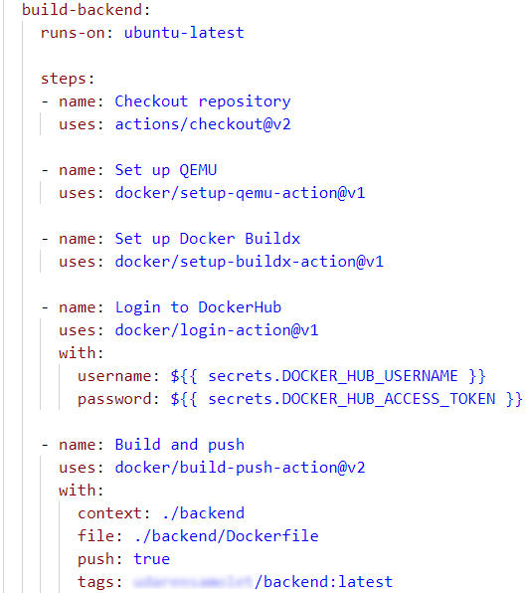

Finally, the build should be successful:

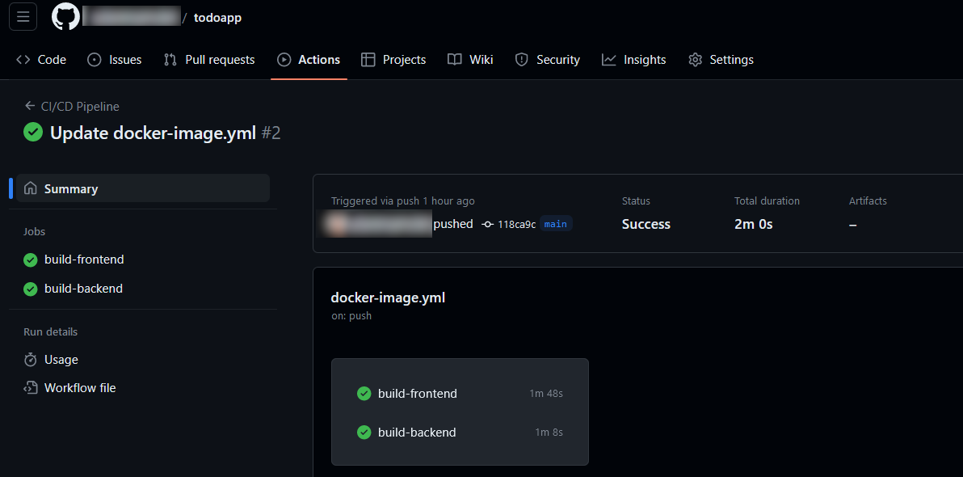

This way we've set up **two** **services**, **frontend** and **backend**, each in its own **Docker** **container**. If you have more microservices, you can follow a similar approach for each.

Then, we used the **docker-compose** file to **orchestrate** these services, defining how they should run together. In this case, we have the frontend and backend services communicating over one network and the backend and MongoDB communicating over another.

The GitHub Actions workflows we've defined are the CI/CD system. On every push to the main branch, it automatically builds the Docker images for your frontend and backend. In a real-life scenario, we would likely also have some testing steps in this workflow to ensure our code is working as expected before it's built into an image and pushed to Docker Hub.

As we're deploying in a local Docker environment, this could be as simple as running **docker-compose up** with the updated images.